**B50RO/B51RO Robotic Mechanical Systems**

**2021 – 2022**

**Team 15:**

|  |  |
| --- | --- |
| **Xander Irvine-Fortescue** | **ai57@hw.ac.uk** |
| **Sylvain Jannin** | **scpj2000@hw.ac.uk** |
| **Seun Ojuoko** | **zo12@hw.ac.uk** |
| **Bethany Livingstone** | **bll3@hw.ac.uk** |
| **Adrian Wendland** | **aw15@hw.ac.uk** |

**Robotics Case Study**

**Project B: Development of An Assembly Robot**

|  |  |  |  |
| --- | --- | --- | --- |
| **Name** | **Signature** | **Date Signed** | **Contribution (%)** |
| Xander Irvine-Fortescue | Xander Irvine-Fortescue | 25/04/2022 | 100% |
| Sylvain Jannin | Sylvain Jannin | 25/04/2022 | 100% |
| Seun Ojuoko | Seun Ojuoko | 25/04/2022 | 100% |
| Bethany Livingstone | Bethany Livngstone | 25/04/2022 | 100% |
| Adrian Wendland | Adrian Wendland | 25/04/2022 | 100% |

**Supervisor:** Dr. Xianwen Kong

**Abstract:** Pick and place robots are frequently used in today’s manufacturing processes to speed up production and maintain a consistency of quality greater than humans can manage. The purpose of this case study was to design, fabricate, and test a robotic arm for this purpose, specifically to pick up a pin and insert it into a hole on a fixed piece of bar. Between the members of the team of varying disciplines, the robot’s mechanical, kinematic, and electrical designs were created and together combined to create a tangible robotic arm which successfully demonstrated that it could pick up a small 3mm pin using a simple mechanical gripper and insert it into the designed pin holder. The arm was evaluated to have a workspace equivalent to a 318mm radius sphere, with the exception that the arm could not reach directly below the base to full extension due to the first arm colliding with the base. While the arm fulfilled the required aims, a few key areas were noted for improvement; firstly, the gripper was designed with a specific size of pin in mind, but it could be modified in the future with a more generic ‘claw’ type gripper that utilizes jagged teeth which affords more operational flexibility. Additionally, the observed movement of the robot arm was not fully stable (jerky), reducing accuracy, something that could be rectified by using a servo easing library in the control code to smooth the servo movements.

# Table of Contents

Design Brief 4

Design & Evolution 5

Kinematics 7

Kinematic Design 7

Denavit-Hartenberg (DH) parameters 7

Homogenous Transform Matrix 8

Forward Kinematics 9

Inverse Kinematics 10

Static Analysis 13

Workspace Analysis 15

Assembly 17

Material Selection & Fabrication 17

Costing 19

Control Systems 20

Electronic Design 20

Trajectory Planning 21

Testing & Evaluation 22

Testing 22

Future Work 24

Conclusion 25

Appendices 26

A. Student Declarations 26

B. Costing 32

# Design Brief

The aim of this case study was to design, fabricate, control, and verify the operation of a robotic arm which would be able to pick up a pin and insert it into a hole on a cylindrical bar, either autonomously or remotely. This robotic arm was to be built with a budget of £60 in addition to any other scrap components that could be obtained.

No other limitations regarding the robot arm were specified.

To achieve the aim of this case study, it would need to consider all elements of the proposed robotic arm including materials, flexibility, control systems, and manufacturability.

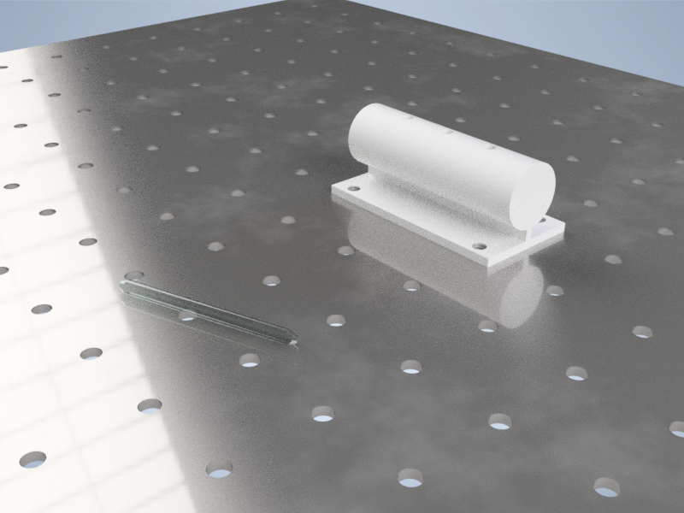

Figure . Artistic rendition of case study setup with glass rod and cylindrical bar to insert rod into.

# Design & Evolution

During the initial design phase, the type of arm was the first consideration. Cartesian, cylindrical and SCARA robot designs were considered, although cartesian and cylindrical designs were deemed to be functional but limited. It was therefore decided upon that the final design would be a serial robot, which would be able to complete multiple other process from the same base design, if the end effector could be modified.

Following this logic, the first CAD model designed was a rough draft of a serial robot with 4 links and 4 servos. At this stage of the design the servos had not yet been chosen, with a draft shape it was assumed 3 larger servos would be used for the first 3 joints, with a smaller servo required for the end effector. Figure 2 shows the first preliminary design draft for the basic shape of the proposed robotic arm. After the first design, the team was provided with 3 x HS-645MG servos and 1 x S3003 servo. Once these servos had been measured, the CAD model could then be updated to fit the shape of the given motors.

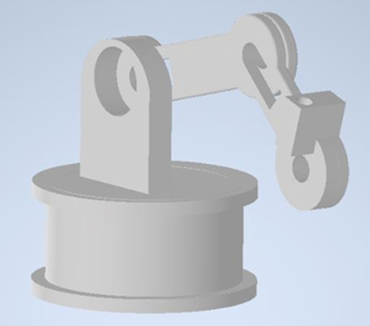

Figure 2. Initial CAD design.

At this stage, the design of the end effector was considered, where simplicity and functionality were the most important aspects. For this reason, the end effector was chosen as 2 gears, one gear connected to a final servo, and one connected the cylindrical extrusion on the end effector, to allow for rotation of the gears. For the end effector, a minimal servo size was required, due to the low torque requirement coupled with the insufficient load (tiny pin). It was therefore decided that an SG90 servo would be suitable for the end effector servo gear. After consideration of the end effector, a new CAD model could be produced using the dimensions of all the required servos, while also including the design for the gear grippers.

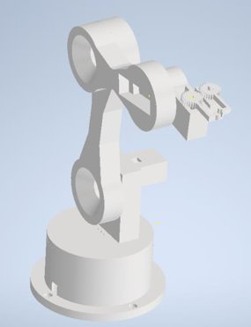

Figure 3. Updated CAD model, before servo gears and Base change (left), and after (right).

The first image of the updated CAD model shows the design without the servo gears, and with the original base top, while the model on the left has an updated base top as well as the end effector gears. Once the parts for the first model had been printed, there were some slight changes that were required during the assembly to allow for the arm to function correctly.

During the assembly of the robotic arm, there were some minor complications which necessitated some design adaptations to allow the final design to function as intended. After the initial CAD model had been printed, assembly of the servos and links could be started. During this initial assembly, the S3-003 Servo was found to be damaged on one side, which affected the stability of the servo once in place. To solve this problem, a new base top was designed with a housing unit for the broken servo, which would connect the servo on one side, while the shape of the housing unit would ensure sufficient stability for the servo while in use.

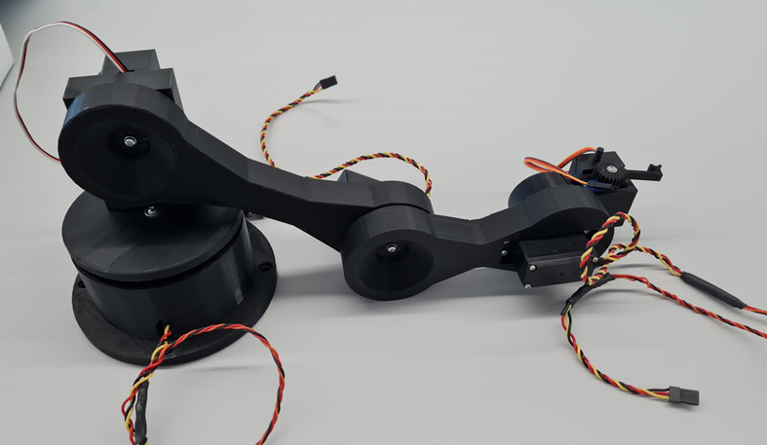

Figure 4. Full constructed assembly.

Figure 5. End connector servo gears.

Additionally, the initial end effector gears would not turn when connected to the SG-90 servo, this was due to the large number of teeth on the servo, and the method for servo-gear connection. It was therefore decided that the servo gears would be reprinted with less teeth (with a slightly different shape), as well as an interior extrusion for the servo horn to be fixed to the servo gear, to allow ease of rotation.

From the initial design to the final design, there weren’t too many changes, the general shape of the robot remained the same, while the connecting links for the servos had to be accurately sized to hold each servo. The only major complications were the reprinting of the gears for the end effector, and the adaptation to the base top for the damaged servo. After these changes, each servo was able to rotate for the necessary range of motion to complete the task. Once the final parts had been printed and assembled, the arm was then ready for testing.

# Kinematics

## Kinematic Design

Kinematics in general is the analytical study of a robot arms motion with disregard to the dynamics for the movement. To understand the kinematics of the designed robot, the degrees of freedom (DOF) must be understood. To calculate DOF the Grubler’s formula is used;

$$DOF=m\left(N-1-J\right)+ \sum_{i=1}^{J}{fi}$$

Which gives 4 DOF.

## Denavit-Hartenberg (DH) parameters

DH parameters are used to turn joints into four parameters, taken using the previous joint as reference. “common normal” is used to calculate the parameters.DH is a common approach to forward kinematics But other approaches can be used to achieve the same result, such as Screw Theory and Hayati-Roberts.

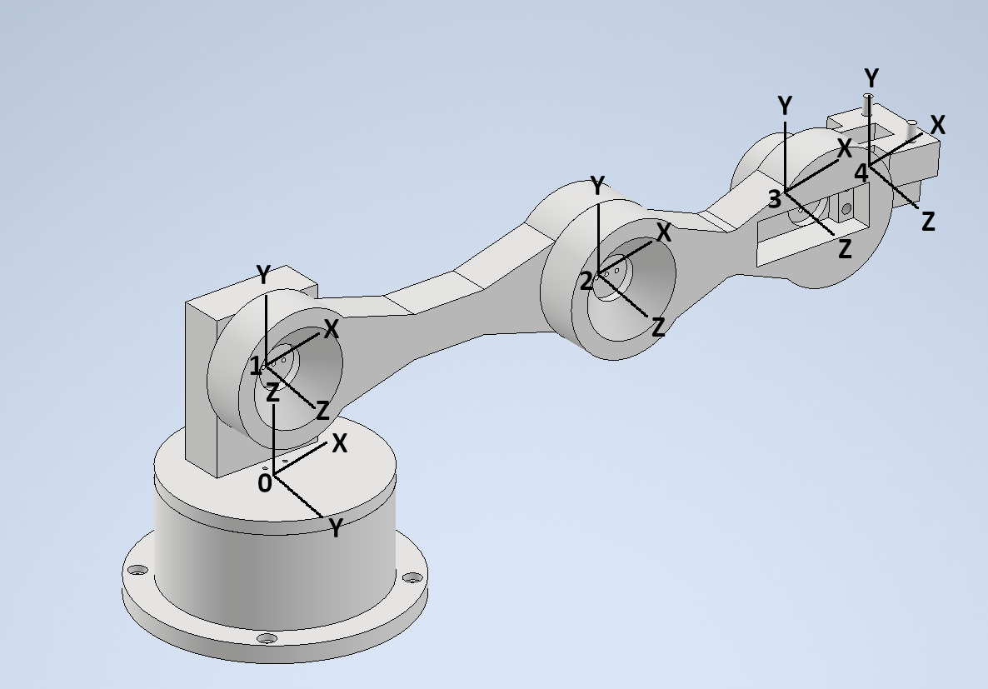

Figure . Robotic arm with local co-ordinate spaces defined for each joint for creation of the DH parameters.

Using the above Figure 6, the following DH matrix is obtained.

Table . DH parameters for robotic arm.

|  |  |  |  |  |
| --- | --- | --- | --- | --- |
| **Link** | **d** | **θ** | **r** | **α** |
| **1** | 47.5 | 0 | 0 | 90 |
| **2** | 0 | 0 | 151 | 0 |
| **3** | 0 | 0 | 100 | 0 |
| **4** | 0 | 0 | 55 | 0 |

Where;

* ***d*** - distance between current and previous x-axis with reference to the previous z-axis.
* **θ** - rotation around the z-axis between the current and previous x-axis.
* **r** - distance between current and previous z-axis (length of common normal)
* **α** - rotation around common normal to between the current and previous z-axis.

## Homogenous Transform Matrix

Using the calculated DH matrix, a Homogeneous Transform Matrix (TM) was computed. The TM can be used to calculate the forward and inverse kinematics. Each joint of the robot populates a 4x4 matrix, this will be used to calculate the TM. The TM is calculated by using the formula; ${}_{i}^{i-1}T={}_{R}^{i-1}T{}_{Q}^{R}T{}_{P}^{Q}T{}_{i}^{P}T$ essentially;

T = Link1 * Link2 * Link3 * Link4

Link 1 $\left[\begin{aligned}0 \\ 90 \\ 47.5 \\ 0\end{aligned}\right]$ = $\left[\begin{matrix}1 & 0 & 0 & 0 \\ 0 & 0 & -1 & 0 \\ 0 & 1 & 0 & 47.5 \\ 0 & 0 & 0 & 1\end{matrix}\right]$

Link 2 $\left[\begin{aligned}151 \\ 0 \\ 0 \\ 0\end{aligned}\right]$ = $\left[\begin{matrix}1 & 0 & 0 & 151 \\ 0 & 1 & 0 & 0 \\ 0 & 0 & 1 & 0 \\ 0 & 0 & 0 & 1\end{matrix}\right]$

Link 3 $\left[\begin{aligned}100 \\ 0 \\ 0 \\ 0\end{aligned}\right]$ = $\left[\begin{matrix}1 & 0 & 0 & 100 \\ 0 & 1 & 0 & 0 \\ 0 & 0 & 1 & 0 \\ 0 & 0 & 0 & 1\end{matrix}\right]$

Link 4 $\left[\begin{aligned}55 \\ 0 \\ 0 \\ 0\end{aligned}\right]$ = $\left[\begin{matrix}1 & 0 & 0 & 55 \\ 0 & 1 & 0 & 0 \\ 0 & 0 & 1 & 0 \\ 0 & 0 & 0 & 1\end{matrix}\right]$

Which gives the final transform as;

$$\left[\begin{matrix}1 & 0 & 0 & 306 \\ 0 & 0 & -1 & 0 \\ 0 & 1 & 0 & 47.5 \\ 0 & 0 & 0 & 1\end{matrix}\right]$$

The TM was calculated by using a simple python script using numpy, code can be found in the Supporting Documents.

## Forward Kinematics

Forward kinematics uses Joint parameters to compute the position of the end effector, it is used in many industries other than robotics such as animation and computer games. The DH parameter was used to simulate the forward kinematics. The simulation software used was Robot Visualization System. Simulating the robot made setting parameters for the joints easier. The forward kinematics of the designed robot uses servo angles to calculate the position of the end effector. This can be calculated using the TM and known servo angles.

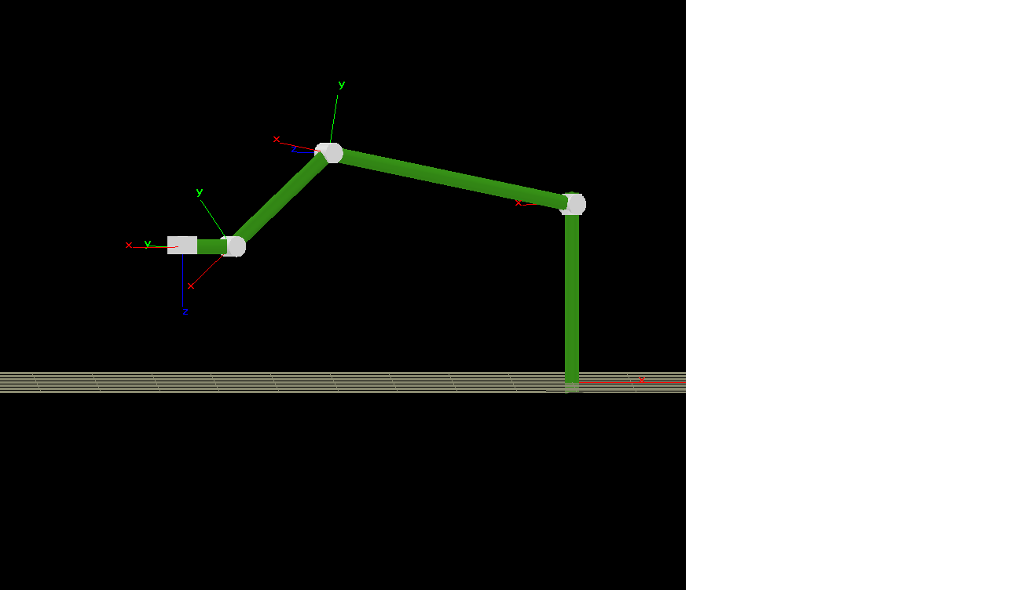

Figure . Kinematic model of robotic arm visualized.

## Inverse Kinematics

Figure : Kinematic schematic, example 1 orientation.

The inverse kinematic can be divided in two parts:

* The (x,y) plan managed by the first servo ($q_{1}$).
* The (r,z) plan managed by the 3 other servos. Where r represents the hypotenuse of x and y.

Therefore:

$$\boxed{q_{1}=atan⁡\left(\frac{y}{x}\right)= atan2\left(y,x\right)}$$

$$\boxed{r=\sqrt{x^{2}+y²}}$$

For the rest, there are 3 servos. The elbow up configuration was chosen to work with for the arm (as the previous figure). Furthermore, to avoid an infinite number of solutions the last angle managed by $q_{4}$ will be set. An angle $φ$ is chosen such that $φ=q_{2}+q_{3}+q_{4}$, $φ$ represents the angle from the r axis to $l_{3}$ (as represented on the figure above). With this, analysed is the 2 joints planar elbow up configuration to the point ($r_{3}, z_{3}$). The position of this point is given by:

$$\boxed{r_{3}=r-l_{3}cos⁡(φ)}$$

$$\boxed{z_{3}=z-l_{3}sin⁡(φ)}$$

Next is applied al-Kashi’s theorem (also known as law of cosines) on the angle between $l_{1}$ and $l_{2}$, referred to as *α* such that ${α=-q}_{3}+π$. To solve the inverse kinematics problem on the ($r, z$) plane, the second joint’s ($q_{2}$’s joint) is set as the origin. The variable *s* is defined as the length between the origin to the point ($r_{3}, z_{3}$), hence:

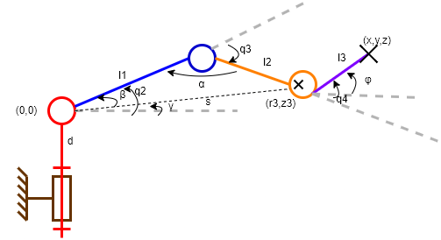

Figure 9. Kinematic schematic, example 2 orientation.

$$s_{3}^{2}=r_{3}^{2}+z_{3}^{2}=l_{1}²+l_{2}²-2l_{1}l_{2}cos⁡(α)$$

$$-cos\left(α\right)=\frac{r_{3}^{2}+z_{3}^{2}-{(l}_{1}²+l_{2}²)}{2l_{1}l_{2}}$$

It is known that:

$${α=-q}_{3}+π$$

$${\cos\left(α\right)=cos⁡(-q}_{3}+π)=cos(q_{3})$$

Thus:

$$-cos\left(q_{3}\right)=\frac{r_{3}^{2}+z_{3}^{2}-{(l}_{1}²+l_{2}²)}{2l_{1}l_{2}}$$

$$\boxed{q_{3}=-arcos\left(\frac{r_{3}^{2}+z_{3}^{2}-{(l}_{1}²+l_{2}²)}{2l_{1}l_{2}}\right)}$$

Setting two new angles: β from s to $l_{1}$ and γ from the r axis to s. So $q_{1}$ is defined such as $q_{2}=γ+β$:

$$γ=atan\left(\frac{z_{3}}{r_{3}}\right)$$

$$β= atan\left(\frac{l_{2}\sin{(q_{3})}}{l_{1}+l_{2}\cos{{(q}_{3})}}\right)$$

$$\boxed{q_{2}=atan\left(\frac{z_{3}}{r_{3}}\right)+atan\left(\frac{l_{2}\sin{(q_{3})}}{l_{1}+l_{2}\cos{{(q}_{3})}}\right) }$$

Once $q_{2}$ and $q_{3}$ are determined, it is easy to deduce $q_{4}$ since it is already known how $φ$ is defined.

$$φ=q_{2}+q_{3}+q_{4}$$

$$\boxed{q_{4}=φ-(q_{2}+q_{3})}$$

In summary:

$$r=\sqrt{x^{2}+y²}$$

$$r_{3}=r-l_{3}cos⁡(φ)$$

$$z_{3}=z-l_{3}sin⁡(φ)$$

$$q_{1}=atan⁡\left(\frac{y}{x}\right)= atan2\left(y,x\right)$$

$$q_{3}= -arcos\left(\frac{{r_{3}}^{2}+{z_{3}}^{2}-({l_{1}}^{2}+{l_{2}}^{2})}{2l_{1}l_{2}}\right)$$

$$q_{2}=\operatorname{atan}\left(\frac{z_{3}}{r_{3}}\right)+atan\left(\frac{l_{2}sin(q_{3})}{{l_{1}+l}_{2}cos(q_{3})} \right)= \operatorname{atan}{2\left(z_{3}, r_{3}\right)}+atan2\left(l_{2}sin(q_{3}), {l_{1}+l}_{2}cos(q_{3}) \right)$$

$$q_{4}=φ-(q_{2}+q_{3})$$

## Static Analysis

To determine the necessary strength of each motor, a static analysis was carried out with the arm at maximum extension holding the pin (this set of conditions would maximise the load carried by each motor).

Firstly, the masses of each component inc. pin were obtained directly through the CAD for a few selected materials (aluminium, PLA, and ABS) to compare savings in weight between each material. Each of these masses creates a weight force at the centres of their respective masses which in turn imparts moments on the arm which need to be counteracted by the motors (Figure 10, M4 counteracts moment from W5+W6, M3 counteracts moment from W4+W5+W6 etc.).

Figure 10. Weights (W*) of each arm component imparting Moments (M*) on joints.

It should be noted that the masses of each component (for PLA and ABS) as taken from the CAD were multiplied by 20% to approximate a typical infill (it would be unrealistic to print the parts at 100% infill). Additionally, the masses of each future motor were neglected as it was assumed they would be light in comparison to the robotic arm components.

The following equations (with respect to Figure 10) represent the moment imparted on that part of the robotic arm due to the weight of each component + pin, and hence the required amount of torque to counteract it:

$$M_{4}=\left(L_{6}+L_{5}\right)W_{6}+L_{5}W_{5}$$

$$M_{3}=\left(L_{6}+L_{5}+L_{4}+L_{3}\right)W_{6}+\left(L_{5}+L_{4}+L_{3}\right)W_{5}+L_{3}W_{4}$$

$$M_{2}=\left(L_{6}+L_{5}+L_{4}+L_{3}+L_{2}+L_{1}\right)W_{6}+\left(L_{5}+L_{4}+L_{3}+L_{2}+L_{1}\right)W_{5}+\left(L_{3}+L_{2}+L_{1}\right)W_{4}+L_{1}W_{3}$$

Table 2. Mass and weight of each component as per Figure 10 with various materials. Note that W1 and W2 are undefined as they do not create a moment on the arm.

|  |  |  |  |  |  |  |
| --- | --- | --- | --- | --- | --- | --- |
| **Component** | **Aluminium** | | **PLA (20% Infill)** | | **ABS (20% Infill)** | |
| Mass (g) | Weight (N) | Mass (g) | Weight (N) | Mass (g) | Weight (N) |
| W1 | N/A | N/A | N/A | N/A | N/A | N/A |
| W2 | N/A | N/A | N/A | N/A | N/A | N/A |
| W3 | 360 | 3.53 | 33.84 | 0.33 | 28.2 | 0.28 |
| W4 | 292 | 2.86 | 27.6 | 0.27 | 23 | 0.23 |
| W5 | 103 | 1.01 | 9.84 | 0.10 | 8.2 | 0.08 |
| W6 | 20 | 0.20 | 20 | 0.20 | 20 | 0.20 |

Table 3. Various lengths corresponding to Figure 10.

|  |  |
| --- | --- |
| **Lengths** | **Length (mm)** |
| L1 | 75 |
| L2 | 75 |
| L3 | 50 |
| L4 | 50 |
| L5 | 37 |
| L6 | 31 |

Table 4. Moments expected (i.e. minimum motor torques required) at each designated motor positions 2-4 as per Figure 10 for selected materials.

|  |  |  |  |
| --- | --- | --- | --- |
| **Joint** | **Moment (Nmm)** | | |
| **Aluminium** | **PLA (20% Infill)** | **ABS (20% Infill)** |
| **M4** | 51 | 17 | 16 |
| **M3** | 315 | 60 | 55 |
| **M2** | 1190 | 169 | 151 |

From the above table, it is apparent that while PLA and ABS are comparable in their motor requirements, solid aluminium would require much stronger motors (up to 1.2 Nm compared to 0.2 Nm for PLA/ABS). Since cost was a fairly tight limit on the design of the arm and that larger motors cost more, it was decided at this point that aluminium would be disqualified as a potential material for the robotic arm.

It is acknowledged that a motor would be present near W5 to operate the end effector, but due to the very small size of the grippers, a small pre-selected motor was considered to be strong enough to operate them.

## Workspace Analysis

A workspace analysis on the robotic arm was carried out to determine its flexibility. To do this, each joint was checked in CAD to determine what range of motion each of the individual joints is capable of. All joints had full 360° of motion except for the 2nd joint; this joint was limited to rotating no more than 34° below the xz-plane, as angles greater than this would cause the arm to collide with the base (Figure 11).

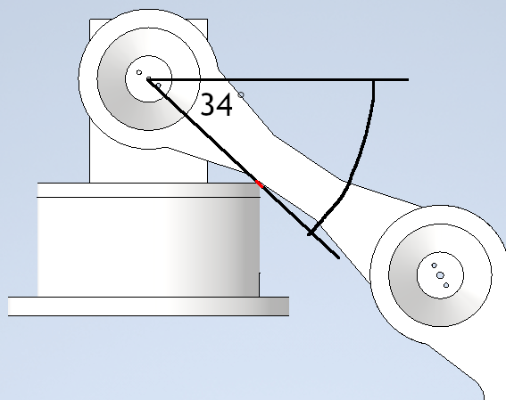

Figure 11. Maximum rotation possible of Joint 2 as it would otherwise collide with the base (point of contact highlighted in red).

Without this single restriction, the workspace of the robotic arm would be–in 2D–a perfect circle with radius equal to the combined length of all of the links (318mm). Taking the restriction into account, the bottom of this circular workspace is ‘cut’ with 2 circles either side of the arm with radii equal to the combined length of the links **minus** the first link (the one whose motion is restricted) (168mm).

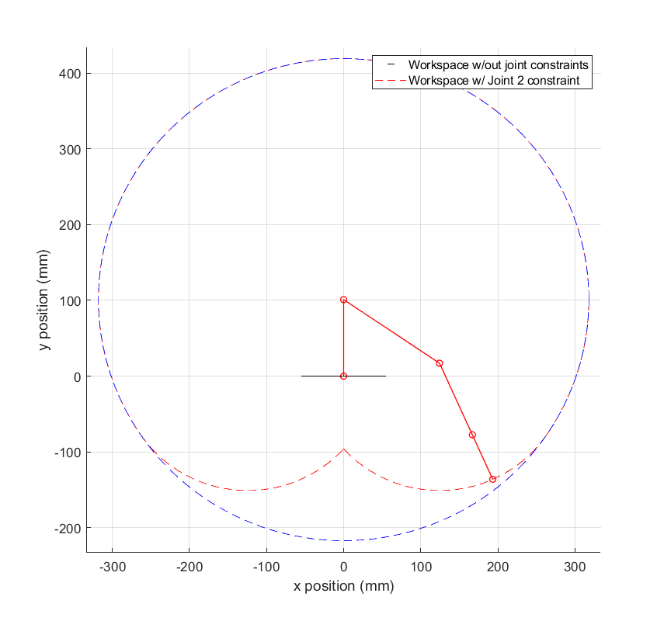

Figure 12. Workspace of the robotic arm with example of arm configuration. Links shown in solid red lines, joints are small red circle markers. Workspaces shown for arm with no joint constraints (blue) and with expected Joint 2 constraint (red).

Figure 12 shows what this looks like in 2D and Figure 13 below shows the workspace in 3D if revolved around the arm’s vertical axis.

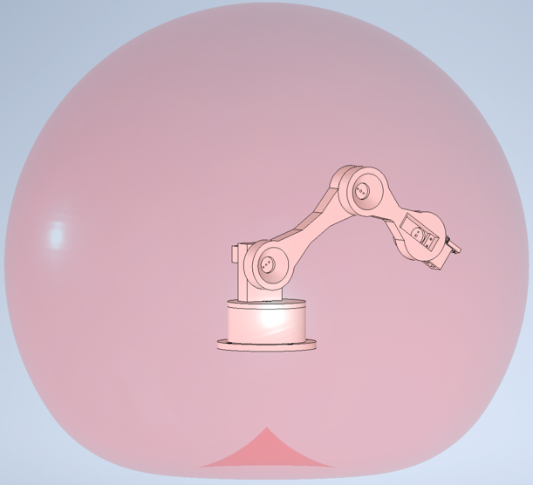

Figure 13. 3D workspace of the robotic arm. Note that instead of a sphere, the bottom of the workspace is rounded inwards due to the first arm joint constraint.

# Assembly

## Material Selection & Fabrication

The choice of material and manufacturing process for all of the parts were settled fairly early in the design process because of a desire to Design for Manufacture (e.g. 3D printing prevents certain geometry like excessive overhangs in certain cases). In fact, the manufacturing process – **3D printing** – was decided on before the material was chosen, for several reasons:

* Plastics as a material are great (cheap and light) but the only low budget method of manufacture is 3D printing.
* 3D printing is more novel and presents more interesting design choices compared to wood or metal assembly.

From there, the choice of material was narrowed down to PLA and ABS (both of which are cheap and lightweight), from which **PLA** was selected as the preferred material primarily due to manufacturing limitations with the home based 3D printing rig.

With the design ready and material selected, the main parameter of the fabrication process remaining was the infill:

* The **non-gripper parts** were printed using a **20% cubic infill structure** – despite each of the parts being functional, a 20% infill was deemed to be sufficient because of the low loads the arm would experience. The choice of cubic infill specifically was made because it brought a good balance of strength in each direction (particularly important for the final link) and printing speed/material usage in contrast to the default grid pattern.

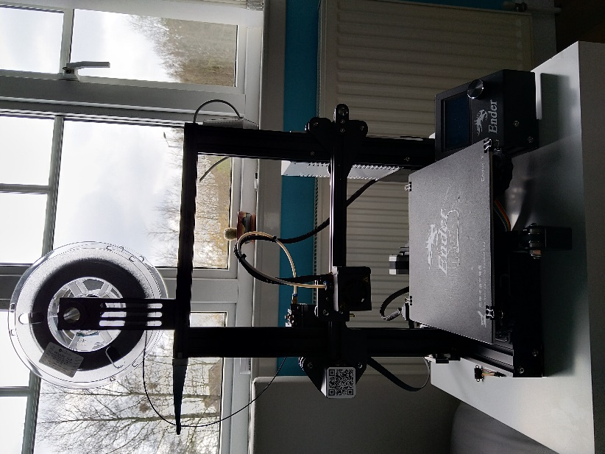

Figure 14. 3D printing rig used for fabrication.

* The **grippers** were printed with a **50% grid infill** **–** 50% because these were small components tasked with actually gripping the test rods so needed to be reliably strong, and a grid infill because the stresses would be mostly within the plane of printing.

## Costing

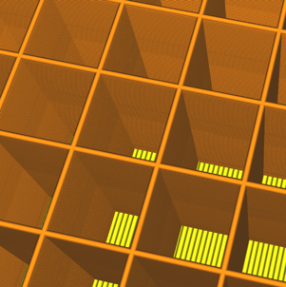

Figure 16. Cubic infill pattern used for fabricating the non-gripper parts, strong in all directions.



Figure 165. Cubic infill pattern used for fabricating the non-gripper parts, strong in all directions.

The budget for this project is £60, provided by Heriot Watt. This budget included all building materials, electrical components, and postage necessary. The final cost of this project came to £38.39, this low cost is due to servos provided by Dr Kong. Parts that were purchased for the project were the SG90 Servo (for the gripper) and a roll of PLA. The PLA was purchased due to limited booking time on university printers, this meant the group could use a personal printer.

Table 5. Table of costs of robot arm.

|  |  |  |  |
| --- | --- | --- | --- |
| **Quantity** | **Part** | **Cost (£) incl VAT** | **Postage (£)** |
| 1 | PLA | 28.91 | 4.95 |
| 1 | SG90 Servo | 3.54 | 0.00 |
| 3 | Servo #1 | 0.00 | 0.00 |
| 1 | Servo #2 | 0.00 | 0.00 |
| 1 | Arduino Uno | 0.00 | 0.00 |
| 1 | Power Supply | 0.00 | 0.00 |
|  |  |  |  |
| **Grand Total** | £38.39 |  |  |

A lot of components are listed as £0.00, this is due to the servos being provided by Dr Kong, and various components supplied by members of the team.

# Control Systems

## Electronic Design

As the assembly robot was designed with four joints, the five servo motors were required for each joint within the structure. Therefore, three HS-645MG and a Futuba S3003 servo motors were used to represent the first four joints, whereas a SG90 servo motor would be for the gripper.

For control, the five-servo motors were connected through a microcontroller (Arduino Uno). Each servo motor was controlled by pulse width modulation (PWM) that regulates the speed of the rotations. Therefore, the servo motors are activated by the PWM pins from the Arduino ports for accurate servo motor rotations. This initiates the torque required for the gears to turn to generate the precise movements for the robotic gripper. Figure 17 shows the Arduino schematic for controlling the servo motors.

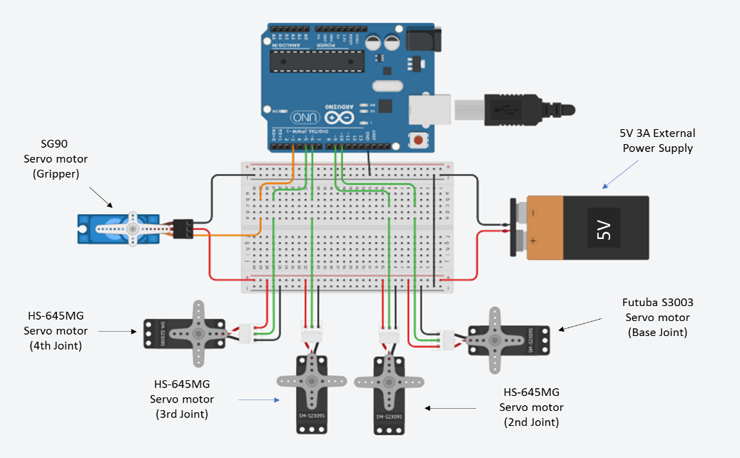

Figure . Circuit diagram of electronics used in the robotic arm.

The construction for the control system began with building a theoretical Arduino to breadboard schematic on TinkerCad. This indicated the correct configurations required to effectively control each servo motors, while also addressing any potential problems in the design. For this scenario, the main problem was the Arduino would naturally struggle to supply enough power to all five servo motors. This would be evident through the last two servo motors failing to create the required torque to successfully rotate the fourth and fifth assembly joints. Therefore, the external 5V 3A supply was incorporated to provide the sufficient power needed to activate each servo motor.

As the Arduino is practically connected the breadboards for the servo motors, the system can be controlled through programmable commands. These are coded in C language that can be downloaded on to the Arduino to execute a sequence of instructions. Based on the kinematics, the procedure is congruent with the previous calculations made for the assembly to perform the intended results.

## Trajectory Planning

The robot is controlled using the inverse kinematic equations found in the “Inverse Kinematics” section, and were implemented on an Arduino. To compute the angles ($q_{1}$, $q_{2}$, $q_{3}$ and $q_{4}$), a different function based on the equations found is created. Four different poses (x,y,z) are defined and called one by one in an infinite while loop. There are also two functions that open or close the gripper: “*pick*” and “*drop*”. The drop function is called when the object is not taken yet, then the pick function is called to close the griper in order to catch the object. The robot moves to the destinations, and once reached, the drop function is recalled and the arm returns to its first position.

Servo motors were chosen because they are piloted in angle, making simpler the implementation, especially in tandem with the servo library in Arduino. Servo objects were created for each used servo, and the servo angle computed in the functions is passed to the servo by using the function “*write*”.

# Testing & Evaluation

## Testing

The code was initially tested on a store-bought arm with similar DOF. This was imperative to the project as it allowed for code to be tested alongside the manufacture of the final robot arm. The test arm was run with the same code as the final project, with variable values changed to suit the specifications of the arm.

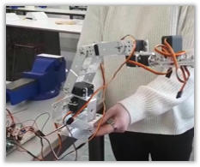

Figure 18. Store purchased robot arm used to test code.

An objective of the arm is to move a pin from a starting point to a designated finish point, The pin is designed by the team and tested with the store-bought arm. During testing it was found that the accuracy of the robot was not suitable for the size of pin, a solution would be to increase the diameter of the pin. [insert picture of pins/holes]

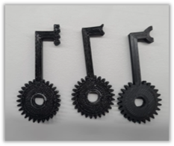

Figure 19. Various types of gripper tested. Final gripper highlighted in red.

Different types of grippers were tested with the designed pin and hole mechanism, though while the kinematic side of the arm struggled to pick up the fixed pin, the gripper showed capabilities of the application. The multiple gripper styles were tested with a suitable substitute for the designed pin, which in this case was a standard pen. The style of gripper that work best in the testing was the larger semi circles, as shown in Figure 19.

On the designed robot, the second joint struggled to operate due to the servo motor being unable to generate enough torque to overcome the opposing weight of the robotic arm. As the assembly would operate, the second servo motor would attempt to rotate, but there would be no evident change in the positioning. A temporary solution was attaching a rubber band from the base to the second joint to ease and reduce the effective weight of the arm, allowing the servo motor to operate properly. This was later changed to a more powerful servo taken from the store-bought arm.

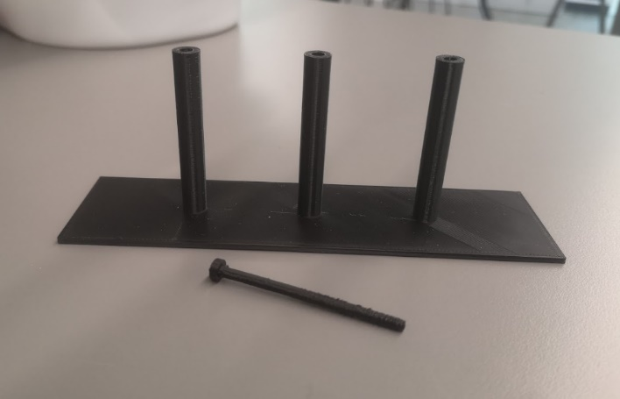

Figure . Testing apparatus with pin and pin holders.

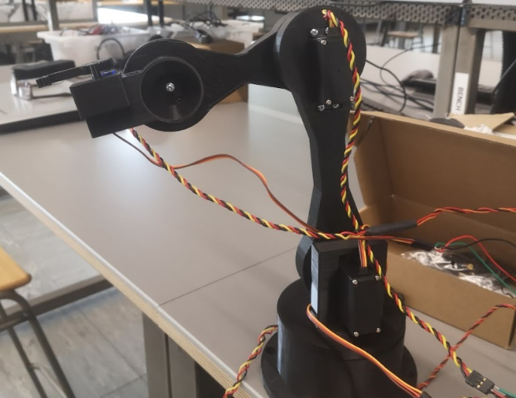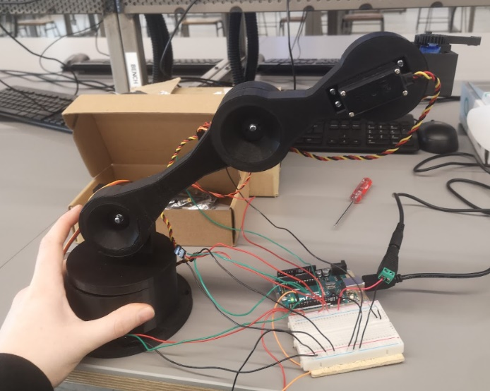

Figure . Robotic arm assembled in 2 different orientations.

## Future Work

Throughout the twelve weeks, most of the criteria based on the assembly had been achieved. However, the robotic arm still had underlying potential that could be strengthened through further enhancements. These improved features ranged from solving current problems with the robot or including an additional that would overall improve the quality of the final product.

The assembly robot heavily relies on the design of the end effector to perfectly grasp targeted objects for placing. Therefore, the robot’s gripper could have a more optimised design to better suit a wider range of applications in holding items. This allows the picked-up items to remain more secure within the robot’s grip, while being less likely to fall out of grasp.

As the position of the end effector transfers from one position to another, it is evident that the movement is quite unstable. The solution to this problem would be using a servo easing library, which smooths the movement of the servo at a desired rate.

Once the assembly is working optimally, a monitoring device could additionally be added to the assembly, such as an ultrasonic sensor. As the sensor would be located alongside the gripper, this could act as an aid for accurately measuring the distance between the gripper and the targeted object. This allows for easier detection because the robot decides the correct position to grip the item, at a specific distance, based on the downloaded code.

## Conclusion

In conclusion, the assignment demonstrated how a group of engineers from varying disciplines, can collaborate to create a functional robotic arm. The process of designing, manufacturing, and evaluating the assembly robot was clearly presented and the objective was achieved, such that the robotic arm could successfully pick up a pin and insert it into the hole of the cylindrical bar. Even with a £60 budget and access to readily available components, the team’s resourcefulness was heavily tested. For future work, the assembly should include servo motors with a stronger torque and encoders for more precise movement in grasping the targeted object.

# Appendices

## Student Declarations

See next page.

|  |  |
| --- | --- |
| **Course code and name:** | B51RO Robotic Mechanical Systems |
| **Type of assessment:** | **Group** |
| **Coursework Title:** | Case Study Report |
| **Student Name:** | Alexander Irvine-Fortescue |
| **Student ID Number:** | H00300413 |

**Declaration of authorship.  By signing this form:**

* **I declare** that the work I have submitted for individual assessment OR the work I have contributed to a group assessment, is entirely my own.  I have NOT taken the ideas, writings or inventions of another person and used these as if they were my own.  My submission or my contribution to a group submission is expressed in my own words. Any uses made within this work of the ideas, writings or inventions of others, or of any existing sources of information (books, journals, websites, etc.) are properly acknowledged and listed in the references and/or acknowledgements section.
* I confirm that I have read, understood and followed the University’s Regulations on plagiarism as published on the [University’s website](https://www.hw.ac.uk/uk/students/studies/examinations/plagiarism.htm), and that I am aware of the penalties that I will face should I not adhere to the University Regulations.
* I confirm that I have read, understood and avoided the different types of plagiarism explained in the University guidance on [Academic Integrity and Plagiarism](https://heriotwatt.sharepoint.com/sites/skillshub/SitePages/Academic-Integrity-and-Plagiarism.aspx)

**Student Signature***:   Alexander Irvine-Fortescue*

**Date**:*21/04/2022*

Copy this page and insert it into your coursework file in front of your title page.

For group assessment each group member must sign a separate form and all forms must be included with the group submission.

**Your work will not be marked if a signed copy of this form is not included with your submission.**

|  |  |
| --- | --- |
| **Course code and name:** | B51RO Robotic Mechanical Systems |
| **Type of assessment:** | **Group** |
| **Coursework Title:** | Case Study Report |
| **Student Name:** | Bethany Livingstone |
| **Student ID Number:** | H00299065 |

**Declaration of authorship.  By signing this form:**

* **I declare** that the work I have submitted for individual assessment OR the work I have contributed to a group assessment, is entirely my own.  I have NOT taken the ideas, writings or inventions of another person and used these as if they were my own.  My submission or my contribution to a group submission is expressed in my own words. Any uses made within this work of the ideas, writings or inventions of others, or of any existing sources of information (books, journals, websites, etc.) are properly acknowledged and listed in the references and/or acknowledgements section.
* I confirm that I have read, understood and followed the University’s Regulations on plagiarism as published on the [University’s website](https://www.hw.ac.uk/uk/students/studies/examinations/plagiarism.htm), and that I am aware of the penalties that I will face should I not adhere to the University Regulations.
* I confirm that I have read, understood and avoided the different types of plagiarism explained in the University guidance on [Academic Integrity and Plagiarism](https://heriotwatt.sharepoint.com/sites/skillshub/SitePages/Academic-Integrity-and-Plagiarism.aspx)

**Student Signature** *(type your name):* Bethany Livingstone

**Date**:25/04/2022

Copy this page and insert it into your coursework file in front of your title page.

For group assessment each group member must sign a separate form and all forms must be included with the group submission.

**Your work will not be marked if a signed copy of this form is not included with your submission.**

|  |  |
| --- | --- |
| **Course code and name:** | B51RO Robotic Mechanical Systems |
| **Type of assessment:** | **Group** |
| **Coursework Title:** | Case Study Report |
| **Student Name:** | Seun Ojuoko |
| **Student ID Number:** | H00298128 |

**Declaration of authorship.  By signing this form:**

* **I declare** that the work I have submitted for individual assessment OR the work I have contributed to a group assessment, is entirely my own.  I have NOT taken the ideas, writings or inventions of another person and used these as if they were my own.  My submission or my contribution to a group submission is expressed in my own words. Any uses made within this work of the ideas, writings or inventions of others, or of any existing sources of information (books, journals, websites, etc.) are properly acknowledged and listed in the references and/or acknowledgements section.
* I confirm that I have read, understood and followed the University’s Regulations on plagiarism as published on the [University’s website](https://www.hw.ac.uk/uk/students/studies/examinations/plagiarism.htm), and that I am aware of the penalties that I will face should I not adhere to the University Regulations.
* I confirm that I have read, understood and avoided the different types of plagiarism explained in the University guidance on [Academic Integrity and Plagiarism](https://heriotwatt.sharepoint.com/sites/skillshub/SitePages/Academic-Integrity-and-Plagiarism.aspx)

**Student Signature** *(type your name):* Seun Ojuoko

**Date**:25/04/2022

Copy this page and insert it into your coursework file in front of your title page.

For group assessment each group member must sign a separate form and all forms must be included with the group submission.

**Your work will not be marked if a signed copy of this form is not included with your submission.**

|  |  |
| --- | --- |
| **Course code and name:** | B51RO Robotic Mechanical Systems |
| **Type of assessment:** | **Group** |
| **Coursework Title:** | Case Study Report |
| **Student Name:** | Sylvain Jannin |
| **Student ID Number:** | H00387879 |

**Declaration of authorship.  By signing this form:**

* **I declare** that the work I have submitted for individual assessment OR the work I have contributed to a group assessment, is entirely my own.  I have NOT taken the ideas, writings or inventions of another person and used these as if they were my own.  My submission or my contribution to a group submission is expressed in my own words. Any uses made within this work of the ideas, writings or inventions of others, or of any existing sources of information (books, journals, websites, etc.) are properly acknowledged and listed in the references and/or acknowledgements section.
* I confirm that I have read, understood and followed the University’s Regulations on plagiarism as published on the [University’s website](https://www.hw.ac.uk/uk/students/studies/examinations/plagiarism.htm), and that I am aware of the penalties that I will face should I not adhere to the University Regulations.
* I confirm that I have read, understood and avoided the different types of plagiarism explained in the University guidance on [Academic Integrity and Plagiarism](https://heriotwatt.sharepoint.com/sites/skillshub/SitePages/Academic-Integrity-and-Plagiarism.aspx)

**Student Signature** *(type your name):*Sylvain Jannin

**Date**:25/04/2022

Copy this page and insert it into your coursework file in front of your title page.

For group assessment each group member must sign a separate form and all forms must be included with the group submission.

**Your work will not be marked if a signed copy of this form is not included with your submission.**

|  |  |
| --- | --- |
| **Course code and name:** | B51RO Robotic Mechanical Systems |
| **Type of assessment:** | **Group** |
| **Coursework Title:** | Case Study Report |
| **Student Name:** | Adrian Wendland |
| **Student ID Number:** | H00215700 |

**Declaration of authorship.  By signing this form:**

* **I declare** that the work I have submitted for individual assessment OR the work I have contributed to a group assessment, is entirely my own.  I have NOT taken the ideas, writings or inventions of another person and used these as if they were my own.  My submission or my contribution to a group submission is expressed in my own words. Any uses made within this work of the ideas, writings or inventions of others, or of any existing sources of information (books, journals, websites, etc.) are properly acknowledged and listed in the references and/or acknowledgements section.
* I confirm that I have read, understood and followed the University’s Regulations on plagiarism as published on the [University’s website](https://www.hw.ac.uk/uk/students/studies/examinations/plagiarism.htm), and that I am aware of the penalties that I will face should I not adhere to the University Regulations.
* I confirm that I have read, understood and avoided the different types of plagiarism explained in the University guidance on [Academic Integrity and Plagiarism](https://heriotwatt.sharepoint.com/sites/skillshub/SitePages/Academic-Integrity-and-Plagiarism.aspx)

**Student Signature** *(type your name):* Adrian Wendland

**Date**:23/04/2022

Copy this page and insert it into your coursework file in front of your title page.

For group assessment each group member must sign a separate form and all forms must be included with the group submission.

**Your work will not be marked if a signed copy of this form is not included with your submission.**

## Costing

